Chapter 8 Quiz Study Guide

- Which element is more electronegative?
  - Zn or Br –

  - Li or Cs –

  - Au or Al –

- Order the following pairs of atoms in order of increasing bond polarity:
H—I H—Cl H--F

- Draw the structural formula and place a partial positive and a partial negative charge on each atom in these molecules. Which molecules are polar? Why?
  - HCl

  - CH₄

  - H₂O

- At cold temperatures, hydrogen bromide, HBr, is a liquid.
  - Draw the Lewis Dot Diagram for HBr. Add dipole arrow

  - Would HBr be attracted to a charged wand? Would it form a round drop on waxed paper? Hint: wax is non-polar! Explain your reasoning.

  - In HBr, what type of bond exists between H and Br?

  - Do you expect HBr to have a smell? Explain.
- Use what you know about molecules to explain why you can’t smell perfume while the bottle is closed, but can smell is once the bottle is open.

- Which can you smell better, cold bread, or warm bread right out of the oven? Explain.

- For the molecules in the table below, do the following steps:
  - Draw Lewis Dot Diagrams. DON’T forget lone pairs!! (think HONC1234 and octet rules)
  - Draw the actual molecular shape. Use electron domains and lone pairs to help you.
  - Draw dipole arrows for each bond between 2 atoms.
  - Draw overall dipole for the molecule if it is polar
  - Name the shape of each molecule. Note: some might be multiple shapes combined. Remember that a single shape is organized around one center atom. Is there is more than one atom to use as a center, there are multiple shapes.
  - Write Y if polar, N if nonpolar

Molecular Formula | Lewis Dot Diagram (a) | Molecular Shape + Dipoles (b, c, d) | Shape Name (e) | Polar Y/N?(f)
CO₂
CH₂O
Molecular Formula | Lewis Dot Diagram (a) | Molecular Shape + Dipoles (b, c, d) | Shape Name (e) | Polar Y/N?(f)
CF₄
PCl₃
H₂S
C₂H₄
CH₃OH

- For the following molecules:
  - Calculate degree of polarity
  - Draw molecule with the direction of polarity (dipole arrow)
  - Determine if the molecules are ionic (I), polar covalent (PC), or nonpolar covalent (NPC)
Molecule | Degree | Direction | I/PC/NPC?
HF
HCl
NaF
CsCl

- For the following molecules, predict if they will smell, and EXPLAIN the reasoning behind your prediction:
Molecule | Smell? Y/N | Reasoning
Hydrogen cyanide, HCN (gas)
Carbon dioxide, CO₂ (gas)
Geraniol C₁₀H₁₈O (liquid)
Zinc, Zn (solid)
Fentanyl, C₂₂H₂₈N₂O (liquid)
Vanillin, C₈H₈O₃ (liquid)
Magnesium chloride, MgCl₂ (solid)

10. If you are looking at a Lewis Dot Structure of a molecule, how do you determine the shape? What do you look at/for?

11. Despite being a small polar molecule, water does not have a smell. Use scientific reasoning to explain why.

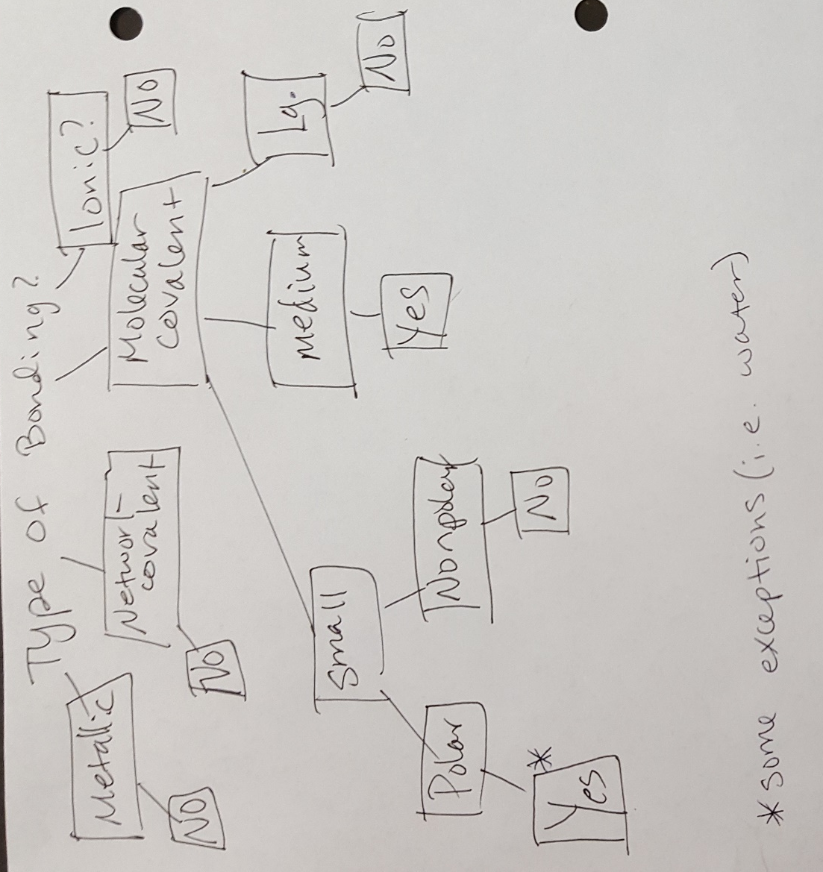

Topics Covered:
- Molecule shape (knowing names of all shapes and determining shapes of a molecule given a molecular structure
  - Linear
  - Bent
  - Pyramidal
  - Tetrahedral
  - Trigonal planar
  - Molecules with more than one shape (ex. tetrahedral around one atom, and bent around another atom, 2 trigonal planar shapes connected, a series of tetrahedra, etc)
- Electron domains (as far as using them to determine molecular shape)
- Polarity:
  - Drawing dipoles (arrow with plus end) on bonds between two atoms
  - Determining overall molecule polarity
  - Determining ends with partial negative and partial positive ends
  - Describing behavior of polar/nonpolar molecules with respect to a charged wand, and tendency to bead up.
  - Determining degree of polarity of a bond between two atoms
  - Determining if bonds are ionic, polar covalent, or nonpolar covalent
  - Explaining difference between ionic, polar covalent, or nonpolar covalent bonds
- Using phase, polarity, size, and bonding type to predict smell (flowchart attached)

Resources: You may use your periodic table and your electronegativity scale on the quiz. You will NOT have a copy of the smell/no smell flowchart.

