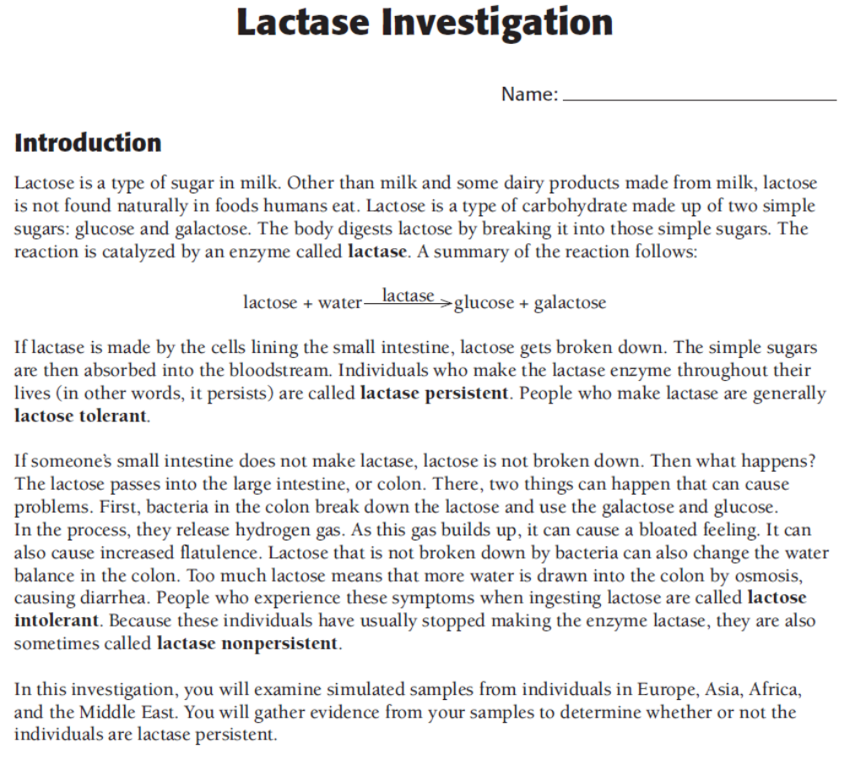
Procedure
- Working individually, locate your three assigned samples on the list of Lactase Results.
- We want to create a map showing which regions of the planet have people with lactase persistence and which do not. Find the countries for your assigned samples on the map.
- Place sticky notes on the map to show which samples do or do not have lactase persistence. Use pink sticky notes for lactase persistence (yes). Use yellow sticky notes for lactase non-persistence (no). 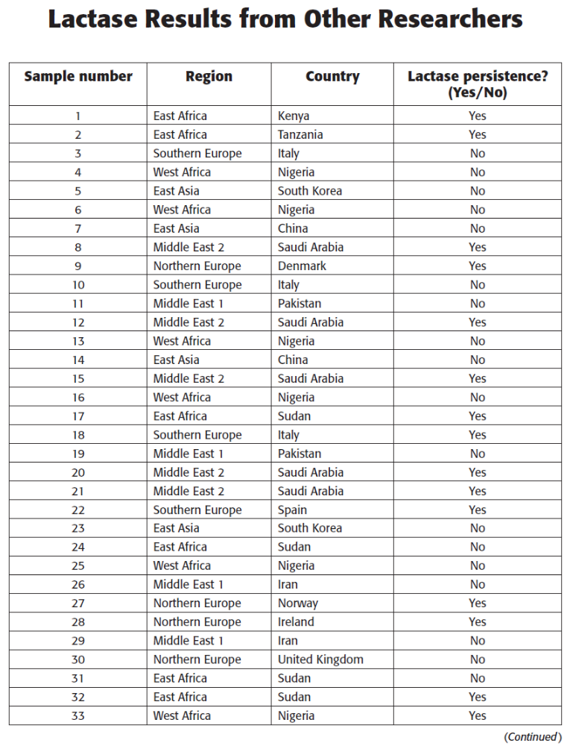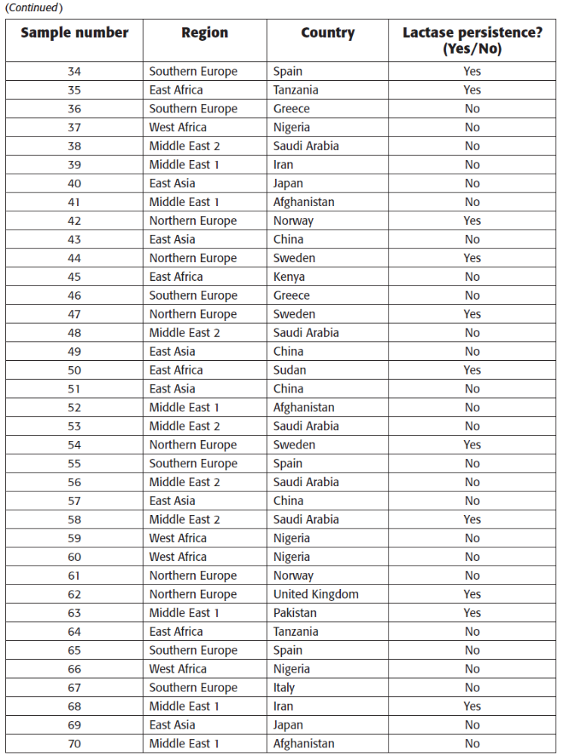
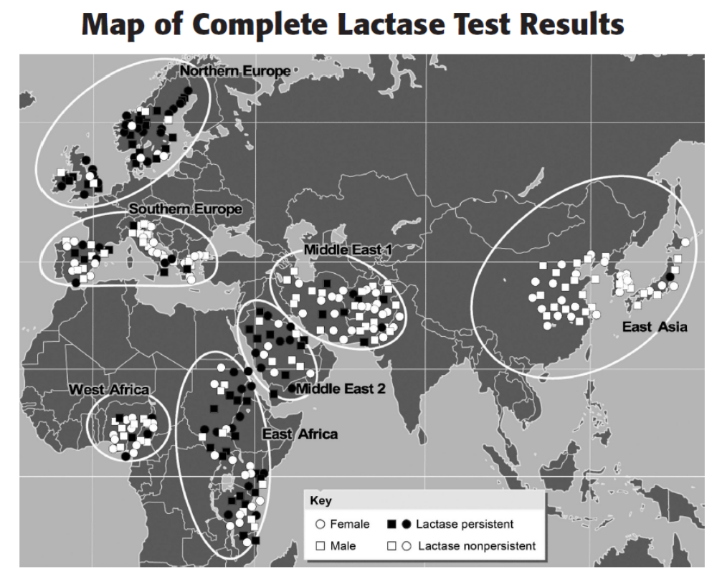

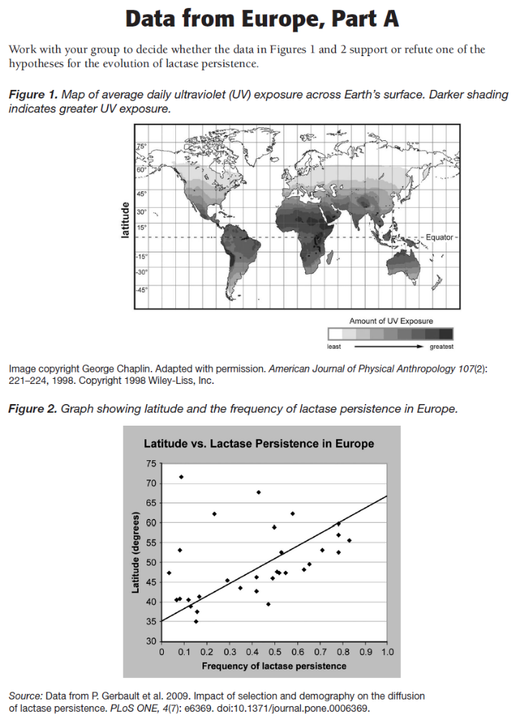
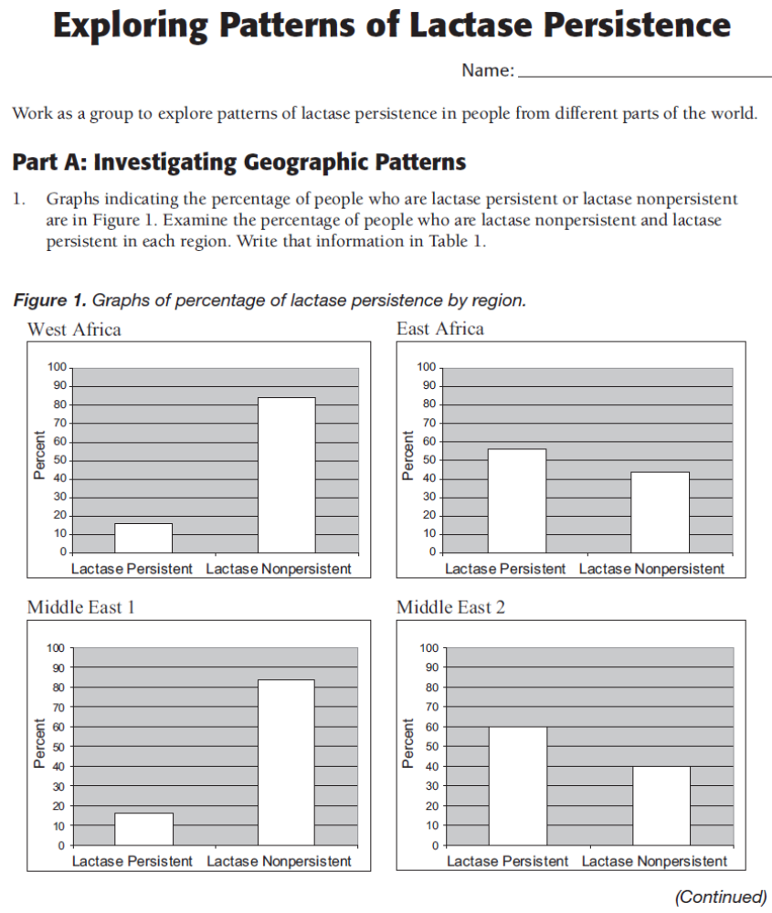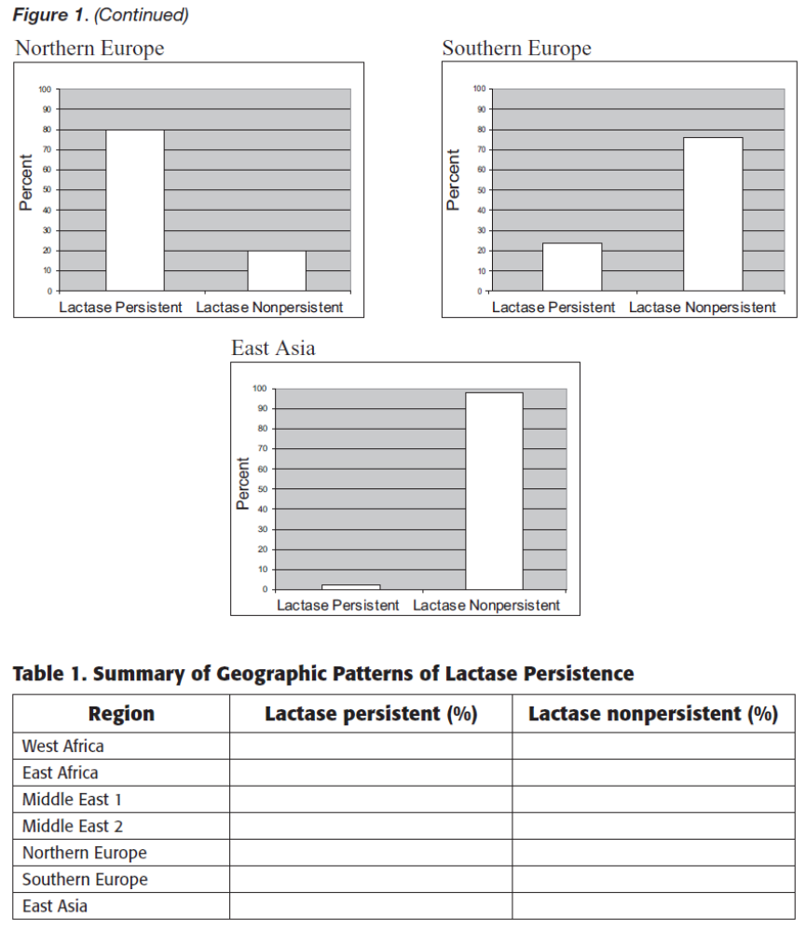
Cultural-Historical Hypothesis

Some cultures have a tradition of herding and milking cows, goats, and/or camels. Cultures that rely on livestock for meat and milk are called “pastoralist”. The culture-historical hypothesis says that individuals who are lactase persistent (lactose tolerant) had a selective advantage in pastoralist populations.
According to this hypothesis, lactase persistent (lactose tolerant) individuals had a higher level of nutrition because they could drink and digest milk. Milk is a high-calorie source of nutrition that is also high in protein. However, some cultures have a large number of individuals who cannot digest lactose. One way to solve this problem is to ferment milk to make cheese. Some cheeses do not have lactose. Yet, the cheese made from fresh milk has about 40 percent fewer calories than fresh milk. So, people who could digest fresh milk could get more calories in their diet than people who ate cheese made from the same amount of milk. Another possibility is that lactase persistent (lactose tolerant) individuals had an advantage because they were able to take in the water from the milk. Milk is an important source of liquid, especially in desert regions.
A higher level of nutrition meant that lactase persistent (lactose tolerant) individuals had higher rates of survival and reproduction or had more children who survived and reproduced. Scientists collected data in Africa to test this hypothesis. They examined different groups of people and determined two things. First, they measured the level of lactase persistence (lactose tolerance) in the group. Second, they estimated the level of pastoralism.

Conclusion Writing: Does lactase persistence vary geographically? Why or why not?

With the graphs provided, you will be writing an argument supporting or rejecting the hypothesis above. You will need to include:
- A claim (Lactase persistence does or does not vary geographically)
- trends in line graph
- actual numbers from the bar graph
- explanation of why data supports your claim
- scientific explanation of why this trend exists.
____________________________________________________________________________________________________________________________________________________________________________________________________________________________________________________________________________________________________________________________________________________________________________________________________________________________________________________________________________________________________________________________________________________________________________________________________________________________________________________________________
____________________________________________________________________________________________________________________________________________________________________________________________________________________________________________________________________________________________________________________________________________________________________________________________________________________________________________________________________________________________________________________________________________________________________________________________________________________________________________________________________
__________________________________________________________________________________________________________________________________________________________________________________________________________________________________________________________________________________________________________________________________________________________________________________________________________________________________________________________________________________________________________________________________________________________________________________________________________________________________________________________________________________________________________________

