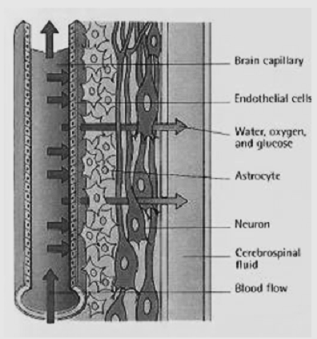
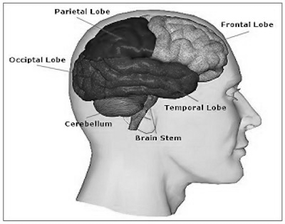
Continuing Explanation on Lena Bedolla
The images (right) show a representation of the blood-brain barrier. When large amounts of water are consumed, this water diffuses into the blood from the digestive system. We know that shortly after leaving the party Lena complained of a headache and dizziness. Use this diagram and your knowledge of osmoregulation to aid in answering the questions below:
- Circle and/or fill in the appropriate responses to the statement below:
When Lena Bedolla consumed a large amount of water, her blood became (hypertonic / isotonic / hypotonic) relative to her brain cells and cerebrospinal fluid, which means _____________________________ _________________________________________________________________________________________________________________________________________________________. This will cause _______________________________ to occur on the selectively-permeable membrane of the blood-brain barrier. Water molecules will flow from the (capillaries / cerebrospinal fluid) to the
(capillaries / cerebrospinal fluid). The nephrons in Lena’s kidneys function against this by excreting (water molecules / NaCl molecules) to balance against the additional water in her body.
- Use your response above to draw a before, during, and after diagram of the blood, cerebrospinal fluid/brain cells, and kidney that shows what microscopic processes are happening to Lena before she drinks the water, during the time she drank water, and after she experiences symptoms of severe headache and mortality.
BEFORE | DURING | AFTER
- Explain how drinking excess water might have caused Lena’s death. _____________________________________________________________________________________________________________________________________________________________________________________________________________________________.

