DNA Base Pairing Worksheet

There are base pairing rules for writing complimentary nucleic acid strands:
- In DNA, A pairs with T and C pairs with G
- In RNA, A pairs with U, instead of T

#1-5: Write the complimentary DNA strand for each given strand of DNA:
C | G | T | A | A | G | C | G | C | T | A | A | T | T | A

T | C | T | T | A | A | A | T | G | A | T | C | G | A | T

A | A | T | G | A | A | T | A | G | C | T | A | G | C | T

G | G | C | A | T | T | C | G | C | G | A | T | C | A | T

C | G | T | T | A | G | C | A | T | G | C | T | T | C | A

#6-10: Now write the mRNA strand for the given DNA strand:
A | T | G | T | C | G | C | T | G | A | T | A | C | T | G

G | A | A | G | C | G | A | T | C | A | G | T | T | A | C

A | A | T | G | A | A | T | A | G | C | T | A | G | C | T

G | G | C | A | T | T | C | G | C | G | A | T | C | A | T

C | G | T | T | A | G | C | A | G | A | T | T | A | C | A

Draw a line between the codons for each strand of mRNA:
11. AGGUCAUGCAUGGGCAUGCAU
12. AGAGAUUCAGCUAGCACGAUA
13. GUCAUCGAUCGAUCGGAUGCC
14. UUUCAGUCAGCUAGCGAUCGU
15. CUAAUGUGGAUCCUGAACGCU

Use the codon chart (p.4) for #16-20. Translate the amino acid sequence for the given mRNA strand. Remember that codons are 3 base pairs long. Below each codon, write the 3-letter abbreviation for the corresponding amino acid.

A | U | G | C | A | C | U | G | U | C | C | U | U | U | C

G | A | G | A | U | C | U | G | G | U | U | G | G | A | A

A | G | C | G | U | A | U | U | A | A | C | G | U | A | U

A | G | U | C | G | A | U | C | G | A | U | G | C | G | G

G | U | C | G | C | U | G | A | U | A | G | C | U | A | U

21. Transcribe the following DNA strand. Then translate the mRNA strand you wrote to into the amino acid sequence:

C | G | T | A | A | G | C | G | C | T | A | A | T | T | A
22. Work backwards! Convert the following amino acid sequence to RNA and then to DNA. Is there more than one possible solution? The 3-letter amino acid code is provided.

Met |  |  | Arg |  |  | Ser |  |  | Ala |  |  | Thr

23. Work backwards again! Convert the following amino acid sequence to RNA and then to DNA. Is there more than one possible solution? The 1-letter amino acid code is provided.

D |  |  | A |  |  | N |  |  | C |  |  | E

24. How many possible codon sequences are there?

25. How many amino acids are there?

26. What pattern(s) do you notice about amino acids with more than one codon sequence? In which letter position in the codon (first, second, or third) is the most variability present? Why do you think that is?

27. What letters of the alphabet are missing from the 1-letter amino acid abbreviations?

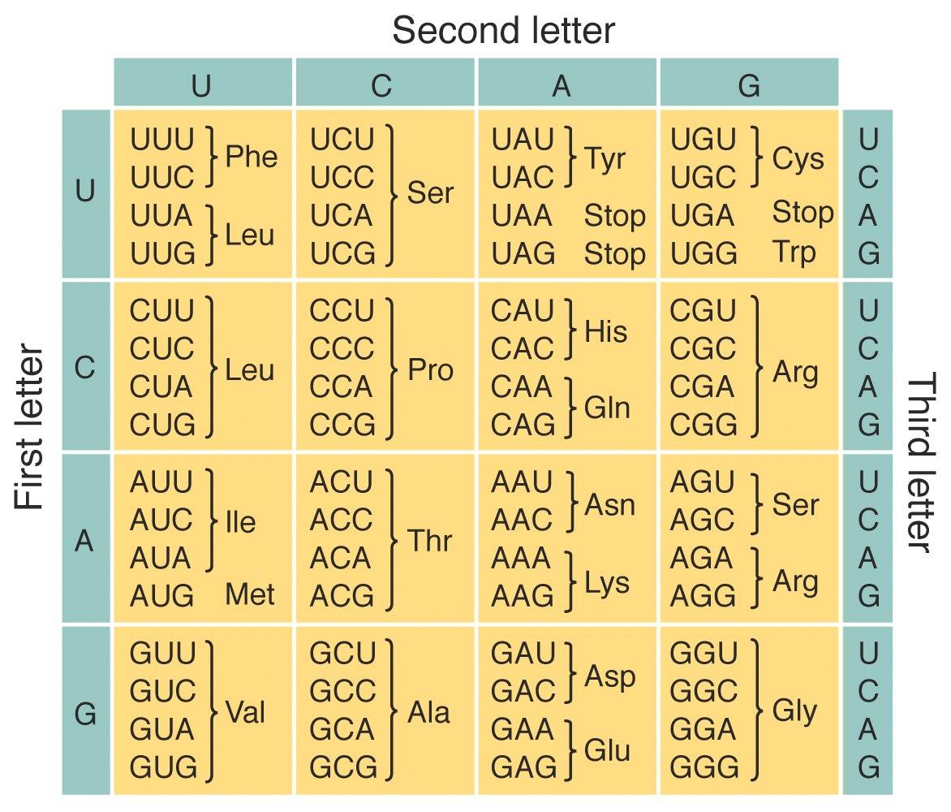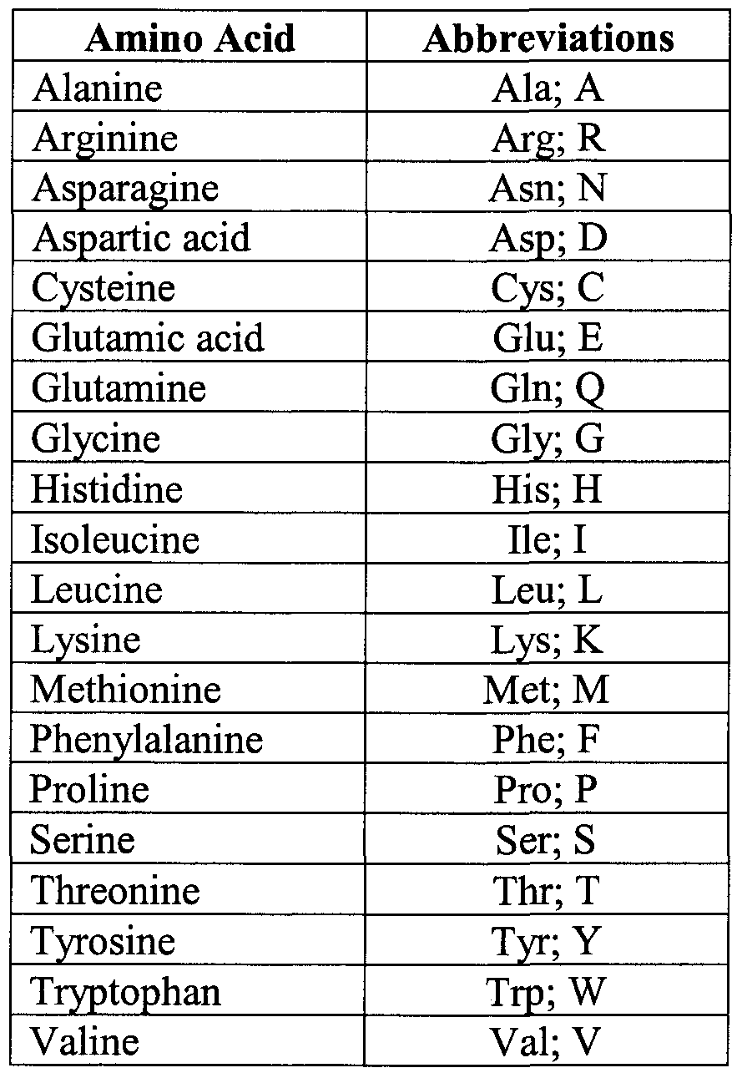

Bonus! What is the longest word you can find using only the letters available in the 1-letter amino acid abbreviations? For extra credit (one point per correctly solved letter), write the word and then solve the corresponding RNA and DNA sequences for the word (as in #23).

